MODULE 4
Lecture # 1

1) Synopsis: Introduction to clipping

2) Target: To study and understand (a) purpose of clipping (b) types of clipping (c) working of clippers etc.
3) Introduction
In particular, we will emphasize the following
(a)Clipping
(b)Types of clippers
(c)Working of clippers.
The circuit with which the waveform is shaped by removing (or clipping) a portion of
the input signal without distorting the remaining part of the alternating waveform is called a clipper. Clipping circuits are also referred to as voltage (or current) limiters, amplitude selectors or slicers. These circuits find extensive use in radars, digital computers, radio and television receivers etc.
4) Revision / Prerequisites
Concepts of clipping

5.1) Concept #1

Clipping
A diode clipping circuit can be used to limit the voltage swing of a signal. Clipper
circuits are used to clip a portion of the waveform. They are also known as amplitude
limiters. The basic principle of clipping circuits is based on the unidirectional property of a diode.
During forward biased condition, diode acts like a close switch and during reverse
biased condition; diode acts like an open switch. Clipping circuit may be classified as flows:
1. Positive clipping circuits.
2. Negative clipping circuits.
3. Biased clipping circuits.
4. Combinational or trapezoidal circuits.
The resistor is used in series with the source to avoid the damage due to excessive
current.

5.2) Concept #2
Positive Clippers
The shunt connected positive clipper, in which the diode conducts for positive half
cycle and hence, the output is a straight line. During the negative half cycle the diode does not conduct and hence the input appears as the output.
In the series positive clipper, when the input voltage is positive, the diode does not
conduct and acts an open circuit and hence the positive half cycle does not appear at the
output, that is the positive half cycle, is clipped off. When the input cycle is negative, the
diode conducts and acts as a closed switch (short circuit), the negative half cycle appears at the output.
In the shunt positive clipper, when the input voltage is positive, the diode conducts and
acts as a short-circuit and hence there is zero signal at the output, i.e. the positive half cycle is clipped off. When the input signal is negative, the diode does not conduct and acts as an open switch, the negative half cycle appears at the output. It is evident that positive clippers introduce as half wave rectifier. Thus the positive clipper has clipped the positive half cycle completely and allowed to pass the negative half cycle of the input signal.

Negative Clippers
The shunt connected negative clipper, in which the diode does not conduct for the
positive half cycle and hence, the output is same as the input. During the negative half cycle, the diode conducts so the output is a straight line.
Biased clipper: In some applications, it is required to remove a small portion of positive or negative half cycle of the signal voltage and hence the biased clipper is used. The name bias is designated because the adjustment of the clipping level is achieved by adding a biasing voltage in series with the diode or resistor. The different types of biased clippers are:
• Biased positive clipper
• Biased positive clipper with reverse polarity of the batteryVR.
• Biased negative clipper
• Biased negative clipper with reverse polarity of the batteryVR.
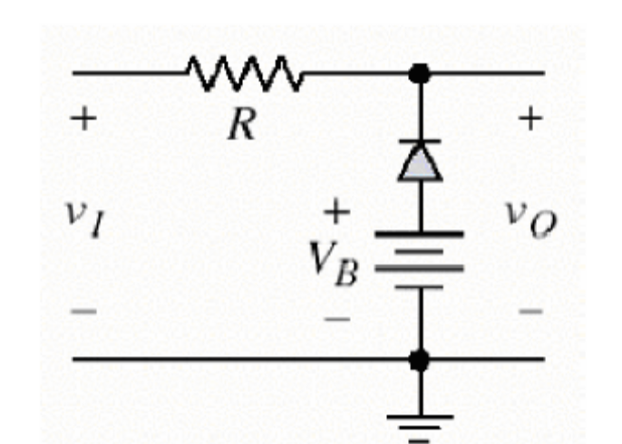
Clipper can be either forward biased or reverse biased.
If a battery is connected in series with the diode in a positive clipper, we get a biased
clipper circuit. Here Vi is the input voltage given.V_{B} is the voltage across the battery and
output voltage is Vo.If the voltage level at input is greater than (Vi+VD)(VD is the voltage drop across the diode ,)which is .7V for silicon and .2V For germanium at 25 degree celsius,the diode conducts. The output voltage becomes (V_{i}+VD) at the instance input voltage exceeds (V_{i}+VD).If input voltage is less than this value diode is reverse biased and acts like an open switch.
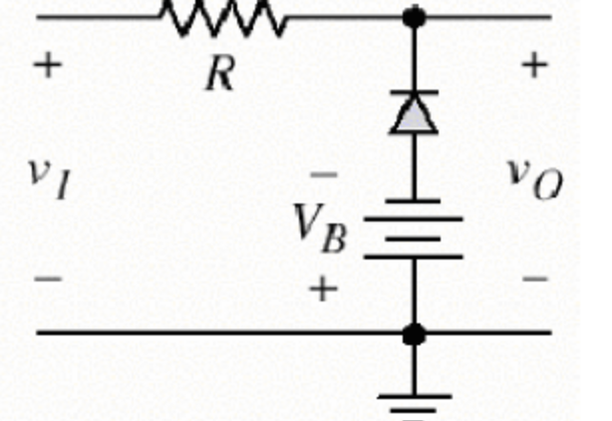
In a biased negative clipper, both the polarities of the diode and battery are reversed. So
a part of negative half cycle is cut off.
Combination of positive and negative clipper is called a double clipper. Here a part of
both negative and positive half cut off.

Combination clipper: This is the combination of a biased positive clipper and a biased
negative clipper. When the input signal voltage V_{i} ≥ +VR1, diode D1 conducts and acts as a closed switch, while D2 is reverse biased and acts as a open switch. Hence, the output voltage cannot exceed the voltage level of +VR2 during the positive half cycle. Similarly the output voltage V_{o} cannot go below the voltage level of –VR2 during the negative half cycle.
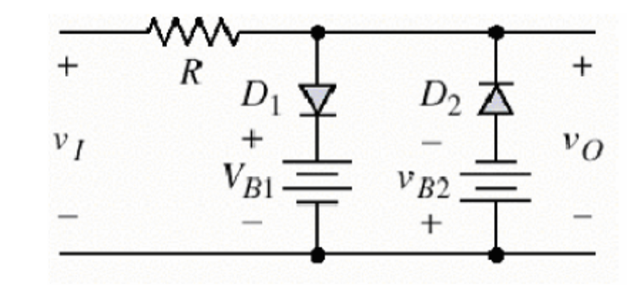

Trapezoidal Clippers
During The Positive half cycle, the diode D1 will be open circuited and the input
appears as the output until, the applied bias voltage value is reached by the source. After this point, the diode is a short circuit and if causes the output to be straight line of conduction. During the negative half, until the bias value is reached, the diode is an open circuit and hence input appears as output, the diode is shorted after this and the out put is the straight line of conduction.
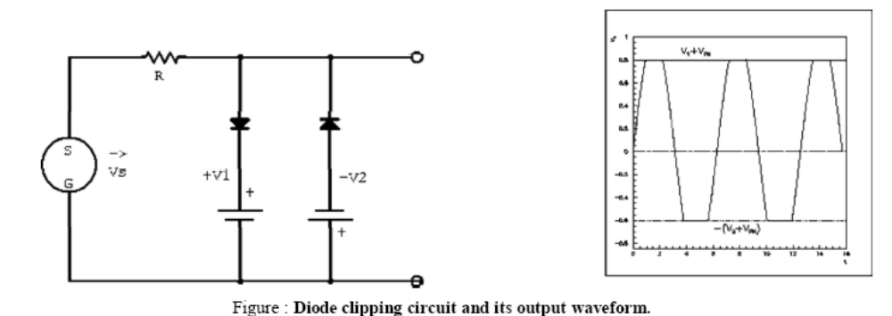

Need of resistance used in clipper
Resistor is used in a clipper to limit the current through the diode. To avoid the
damage due to excessive current through it. Usually in a clipper, diode operates in two
modes, either ‘ON’ or ‘OFF’. When the diode is ON, the series resistance must be much
higher than forward resistance of the diode because almost all input voltage will drop across the input resistor. But when the diode is OFF, series resistance must be very smaller than the reverse resistance of the diode. The value of resistance used in a clipper is the mean of forward resistance and reverse resistance. It is given by
Resistance, R= √ (Rf.Rr)
Where R_{f} – is the forward resistance of the diode and
R_{r} – is the reverse resistance of the diode.
Applications
There are numerous clipper applications. In general clippers are used to perform one of the
following two functions:
• Changing the shape of the waveform.
• Circuit transient protection.
Changing the shape of waveform.- Clippers can alter the shape of a waveform. For example
a clipper can be used to convert a sine wave into a rectangular wave, square wave etc.They
can limit either the negative or positive alteration or both alternations of an a.c. voltage.
Circuit Transient protection.-Transients can cause considerable damage to many types of
circuits e.g. a digital circuit .In that case a clipper diode can be used to prevent the transient
from reaching that circuit.

6.0) Summary
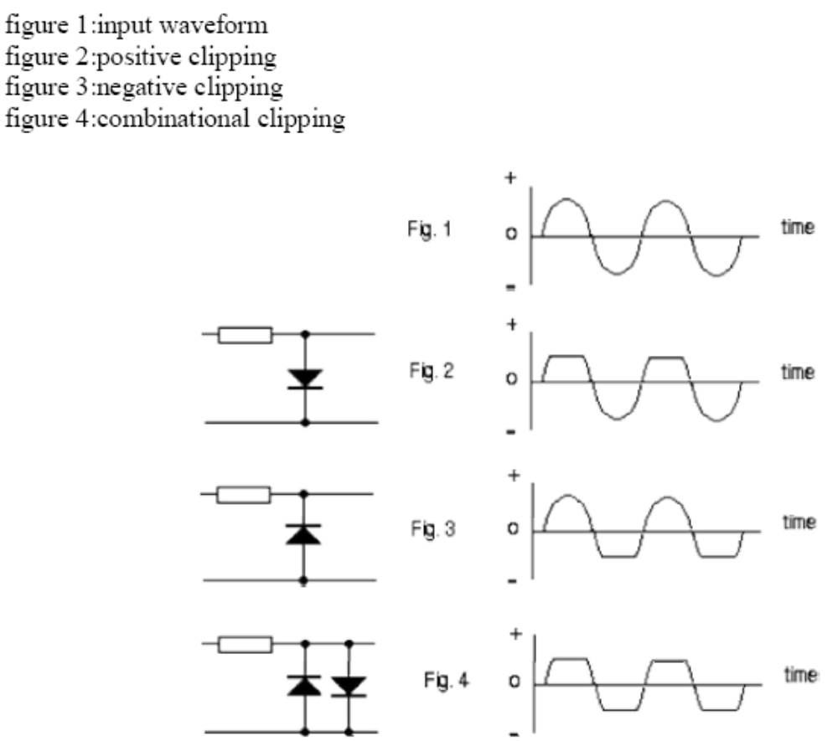
7.0) Exercise questions
Lecture # 2

1) Synopsis: Introduction to clamping

2) Target: To study and understand (a) purpose of clamping (b) types of clamping (c) working of clampers etc.
3) Introduction
In particular, we will emphasize the following
(a)Clamping
(b)Types of clampers
(c)Working of clampers.
Clamping network shifts (clamps) a signal to a different dc level, i.e. it introduces a dc
level to an ac signal. Hence the clamping network is also known as dc restorer. These circuits find application in television receivers to restore the dc reference signal to the video signal. During the positive half cycle, the diode conducts, i.e. it acts like a short circuit. The capacitor charges to V volts. During this interval, the output which is taken across the short circuit will be Vo = 0 V. During the negative half cycle, the diode is open. The difference between clipping and clamping circuits is that while the clipper clips off an unwanted portion of the input waveform, the clamper simply clamps the maximum positive or negative peak to a desired dc level

4) Revision / Prerequisites
Concepts of clamping

5.1) Concept #1

Clamping
When a signal drives an open-ended capacitor the average voltage level on the output
terminal of the capacitor is determined by the initial charge on that terminal and may
therefore be quite unpredictable. Thus it is necessary to connect the output to ground or some other reference voltage via a large resistor. This action drains any excess charge and results in an average or DC output voltage of zero.
A simple alternative method of establishing a DC reference for the output voltage is
by using a diode clamp as shown in figure . By conducting whenever the voltage at the output terminal of the capacitor goes negative, this circuit builds up an average charge on the terminal that is sufficient to prevent the output from ever going negative. Positive charge on this terminal is effectively trapped.
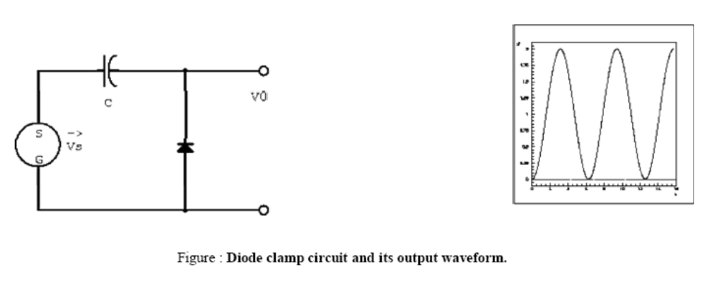

5.2) Concept #2
Negative clamping circuit

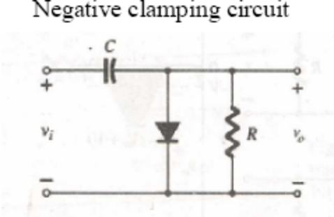
The clamping network shown above is a negative clamping circuit that will clamp the
input signal to a negative dc level.

During the interval 0→ T/2 the network the network will appear as shown below with the diode in the ‘on` state effectively shorting out the effect of the resistor R. The resulting RC time constant is so small that the capacitor will charge to V volts very quickly. During this interval the output voltage is directly across the short circuit and vo = 0V.
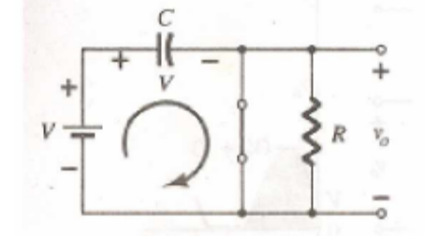
When the input switches to the –V state, the network will appear as shown below with the open-circuit equivalent for the diode determined by the applied signal and stored voltage across the capacitor – both `pressuring’ current through the diode from cathode to anode. Since vo is in parallel with the diode and resistor, applying Kirchoff’s voltage law around the input loop will result in

-V-V-vo = 0
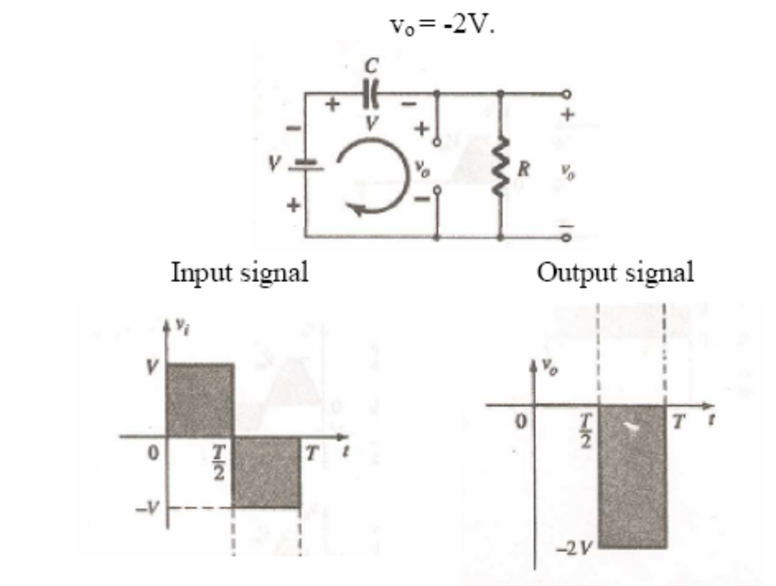
6.0) Summary
7.0) Exercise Questions

Lecture # 3

1) Synopsis: Introduction to Differentiator

2) Target: To study and understand (a) working of differentiator
3) Introduction
A circuit in which the output voltage is directly proportional to the derivative of the
input signal is called differentiator circuit i.e. v0=d/dt(input). A differentiating circuit can be arranged by a simple RC series circuit.
As the RC circuit is very small with respect to the time period of input and exceed much
greater than R, a sharp narrow pulse is obtained as the output when a square wave is given as the input. During early part of the half cycle, the capacitor gets charged. But during the
remaining part of the half cycle, output is zero as the capacitor voltage utilizes input voltage and there can be no current flow. Thus we get a sharp pulse during the start of each half cycle and remaining part has zero output.

4) Revision / Prerequisites
Concept of differentiation
5.1) Concept #1

A differentiator is a high pass RC circuit having a very small time constant. It is a
circuit which gives an output voltage proportional to the derivative of the input voltage. A high pass RC circuit is a circuit, which allows only high frequency to pass through.
The output current I = C dVi/dt.
∴V_{out}= R C dVi/dt
∴Vo α dV_{i}/dt
For a high pass RC circuit to act as differentiator time constant (τ) of the circuit (RC)
should be very much less than the input time period (T). Here if we give a constant input we get no output. For sine wave as input we get cosine wave as output. For square wave we get narrow pulses as output.
5.2) Concept #2
A circuit in which the output voltage is directly proportional to the derivative of the
input signal is called differentiator circuit i.e. v₀=d/dt(input). A differentiating circuit can be arranged by a simple RC series circuit. Here the values of R and C are selected in such a way that the time constant (RC) of the circuit should be very small than the time period of the input wave and reactance of the capacitor is very large as compared to the value of the resistor. Thus the current flowing in the differentiator circuit is to a large extent decided by the capacitive reactance; the current will be leading the input voltage by 90 degrees approximately. Due to this current, the voltage developed across the resistor also leads the input voltage by 90 degrees.
If the input is a sinusoidal signal and given by
v_{i}=V sin (ωt)
Then the output will be leading this voltage by 90 degrees.
v_{o}=Vsin (ωt+90)= V cos(ωt).
Thus we find that the output is a differentiated form of the input signal. This can be proved mathematically.
The output voltage V_{O}= i*R
But since XC>>R, the current (i)is dependent upon capacitor alone. Therefore, the rate of
change of charge across the capacitor gives the current
i= dQ/dt
but the charge Q across the capacitor C is given as
Q=C*V_{C}
Where V_{C} is the voltage across the capacitor
i=d Q/dt = d/dt(C*V_{C}) =C* d(vt)/dt
V_{o}= i* R=CR*d/dt (vt)
When a dc voltage is applied to the differentiating circuit, its output will be zero since the
derivative of a constant is zero. For a square wave input, the differentiator output will be
sharp narrow pulses. When the input to the differentiator circuit is a triangular wave, the
output will be a square or rectangular wave. For a sine wave input, the output of the
differentiator will be a cosine wave.
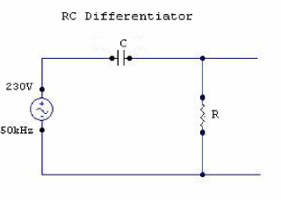
5.3) Concept #3
Output waveforms for a differentiating circuit.

The output waveform from a differentiating circuit depends upon the time constants and
shape of the input wave. Three important cases will be considered.
When input is a square wave.-When the input fed to a differentiating circuit is a square
wave, output will consist of sharp pulses. During the OC part of the input wave, its amplitude changes abruptly and hence the differentiated wave will be sharp narrow pulse. However during the constant part CB of the input, the output will be zero because the derivative of a constant is zero.
Since time constant RC of the circuit is very small w.r.t time period of input wave and
Xc >>R, the capacitor will become fully half cycle, the output of the circuit will be zero
because the capacitor voltage neutralizes the input voltage and there can be no current flow through R.Thus we get a sharp pulse at the output during the start of each half cycle of input wave while for the remainder part of the half cycle of input wave , the output will be zero. In this way, a symmetrical output wave with sharp positive and negative peaks is produced. Such pulses are used in many ways in electronic circuits e.g. in television transmitters and receivers, in multivibrators to initiate action etc.
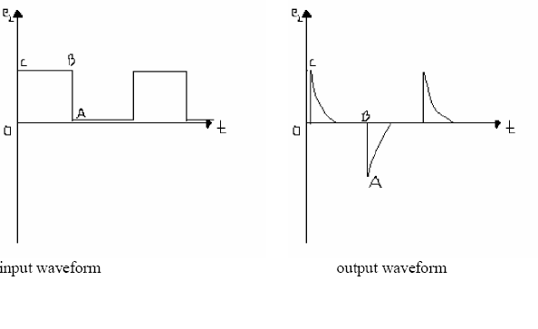
When input is a triangular wave.-When the input fed to differentiating circuit is a triangular wave, the output will be a rectangular wave.
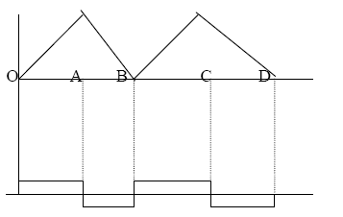
During the period OA of the input wave its amplitude changes at a constant rate and
therefore the differentiated wave has a constant value for each constant value for each
constant rate of change .During the period AB of the input wave, the change is less abrupt so that the output will be a very narrow pulse of rectangular form. Thus when a rectangular wave is fed to a differentiating circuit , the output consists of a succession of rectangular waves of equal or unequal duration depending upon the shape of the input wave. When input is a sine wave.- A sine wave input becomes a cosine wave and a cosine wave input becomes an inverted sine wave at the output .

Lecture # 4

1) Synopsis: Introduction to Integrator

2) Target: To study and understand (a) working of integrator
3) Introduction
Integration is a summation of area. An integrating circuit produces an output voltage
which is proportional to the area enclosed by the input waveform. The shape of the output
voltage waveform is dependant upon the relationship between the time constant (RC) and the pulse width (PW). An integrating circuit is an RC circuit with the output taken across the capacitor and RC ≥ (10 x PW).
4) Revision / Prerequisites
Concept of integration
5.1) Concept #1

The RC integrator is typically a series RC circuit that uses the capacitor to develop its
output. Since voltage cannot change instantly across a capacitor, because it takes time to
charge, the output of an integrator lags the input voltage. When a sine wave voltage is applied to an integrator little or no distortion takes place. In other words, when a sine wave voltage is applied to the input a sine wave voltage develops across the integrator's output (the capacitor). The output is attenuated, however, and lags Va.

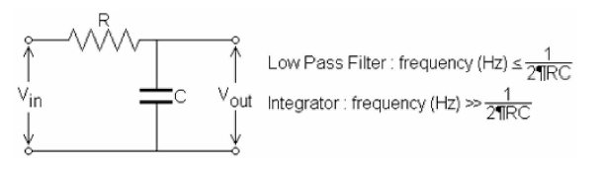
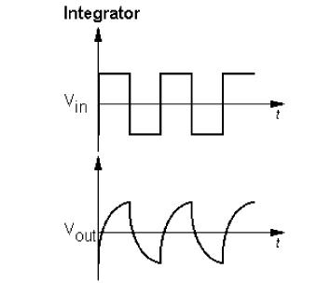
The input to our integrator is a square wave and it undergoes a great amount of
distortion as it is processed by the RC integrator circuit. The first thing to go is the sharp
corner of the square wave. 90-degree corners of a waveform represent very fast voltage
transitions. Since the voltage across a capacitor cannot change instantly (because charging and discharging require time), and since an integrator uses a capacitor to develop its output, these transitions are lost on the integrator's output. The pulse portion of the wave is the time period in which the capacitor is forced to charge.” idle" or "off" time is the time the capacitor is given to discharge.
5.2) Concept #2

The output waveforms for an integrating circuit.

The output waveform from an integrating circuit depends upon time constant and shape of the input wave. Two important cases are:
When input is square wave.- When the input fed to an integrating circuit is a square wave, the output will be triangular wave .As integration means summation therefore , output from an integrating circuit will be the sum of all the input waves at any instant. This sum is zero at A and goes on increasing till it becomes maximum at C.After this the summation goes on decreasing to the onset of negative movement CD of the input.

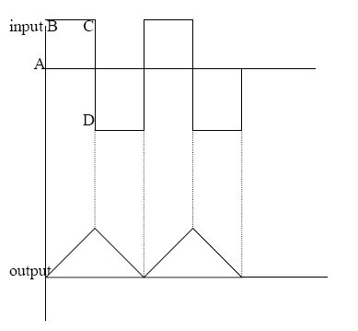
When input is rectangular wave. When the input fed to an integrating circuit is a rectangular wave, the output will be a triangular wave.

5.3) Concept #3

RC Integrator is a low pass RC circuit in which the output is taken across capacitor.
The low pass RC circuit gives considerable gain when low frequency signal is applied. It is because of the high reactance offered by the capacitor at low frequencies. The integrator circuit gives the output proportional to the integral of the input signal.
Voltage across the capacitor V_{o} = 1/C∫idt

Ie, 1/RC∫Vidt

V_{o}∝ ∫Vidt

The gain shown by this circuit decreases considerably with increase in frequency.
This gives triangular wave to square wave input, cosine wave to sine wave input and a
parabolic wave to a triangular wave input.
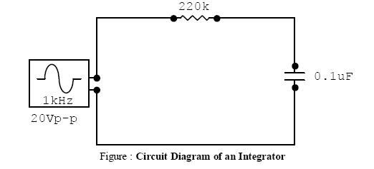

Lecture # 5

1) Synopsis: Introduction to Astable multivibrator

2) Target: To study and understand (a) working of Astable multivibrator

3) Introduction
Multivibrator is basically a two-stage amplifier with output of one supplied back to
the input of the other .
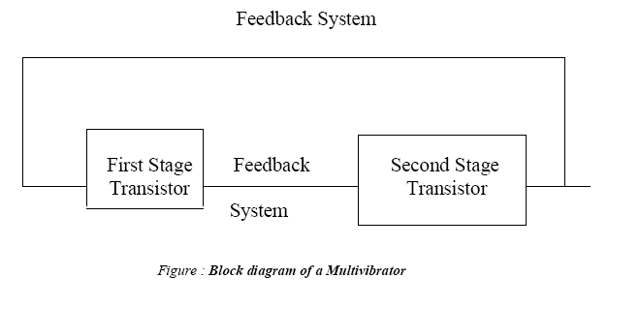

4) Revision / Prerequisites
Concept of multivibrators
5.1) Concept #1

Multivibrator is a switching circuit and may be defined as an electronic circuit that
generates non-sinusoidal waves, such as rectangular waves, saw tooth waves, square waves etc. Multivibrators are capable of storing binary numbers, counting pulses, synchronsing arithmetic operations and performing other, essential functions in digital systems. In a multivibrator, each amplifier stage supplies feedback to the other stage in such a way that one transistor is driven to saturation and the other to cut-off or vice-versa. This is termed as the state of the multivibrator. The condition in which the multivibrator may remain indefinitely until the circuit is triggered by some external signal is termed as the stable state.
There are only two possible states of a multivibrator are as follows:
First state: Transistor T1 ‘on’ and transistor T2 ‘off’
Second state: Transistor T1 ‘off’ and transistor T2 ‘on ’
Depending upon the type of coupling network employed, the multivibrators are
classified into the following three categories.
1. Astable or free-running multivibrator.
2. Monostable or single-shot multivibrator.
3. Bistable or flip-flop multivibrator.
The first one is the non-driven type whereas the other two are the driven type (also called
triggered oscillators).
Multivibrators are used for various purposes such as generation of non-sinusoidal
waveforms ( square, rectangular, sawtooth etc.) and pulses occurring periodically, frequency division, synchronized generation of pulses and extended waveforms, generation of time delays, storage of binary bit of information etc.

5.2) Concept #2

In astable multivibrator both transistors are coupled to each other through capacitors
as shown in the circuit diagram. Whichever transistor is off at any moment cannot remain off indefinitely; its base will become forward biased as that capacitor charges towards +5 volts.
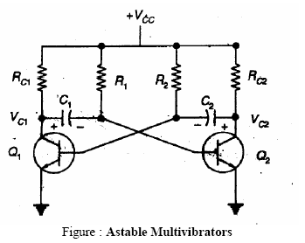
Once that happens, that transistor will turn on, thereby turning the other one off. If we
pick a moment when Q1 has just turned off and Q2 is on, then the left end of C2 is at -5 volts. This negative voltage decreases as C2 charges through R2 towards +5 volts. However, the moment C2 charges enough to provide forward bias to the base of Q1, Q1 turns on and the 5 volt drop in Q1's collector voltage is coupled through C1 to the base of Q2. This turns Q2 off at once. As we saw in the previous experiment, the time that Q1 remains on and Q2 remains off is 0.693RC, which for the component values shown here is about 1 second.

Now Q2 is held off while C1 charges through R1, until Q2's base becomes forward
biased. At that point the transistors switch states again and the whole thing starts over. There is no stable state where the circuit can come to rest, so this circuit is known as an astable multivibrator.

The time Q2 remains off is set by R1 and C1, just as the time Q1 remains off is set by
R2 and C2. For our circuit, the components are of the same values on each side, so the timing will be the same on each half of the cycle. This is not required; the two halves of the circuit can have totally different time intervals. They actually operate independently of each other, even though they work together.

Since this particular circuit will spend about 1 second on each half cycle, the total
cycle time, or period, is about 2 seconds. The operating frequency of the circuit is the
reciprocal of the period, or 0.5 Hz.
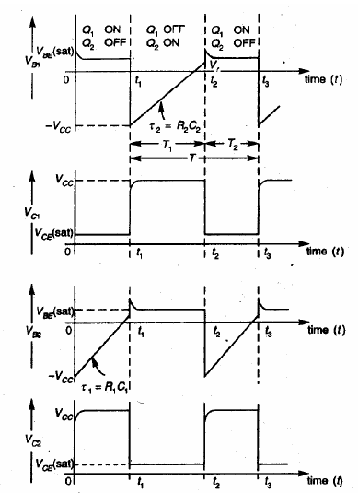

Lecture # 6

1) Synopsis: Introduction to Monostable multivibrator

2) Target: To study and understand (a) working of Monostable multivibrator

3) Introduction
4) Revision / Prerequisites
Concept of multivibrators
5.1) Concept #1

The monostable configuration consists of two amplifier stages interconnected in such
a manner as to possess one stable state. The circuit diagram of a monostable multi is shown in fig 1.The output of transistor A1 at y2 is coupled to the input at x1 through a resistor attenuator in which C1 is a small commutating capacitor. The dc coupling found in a binary from y1 to x2 is here replaced by capacitive coupling through C. While the resistor R at the input of A2 is shown returned to the supply voltage VCC, this feature of the circuit is not essential and R may be returned to a lower potential.

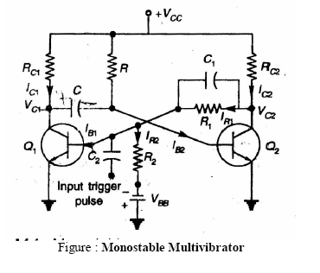

As you can see in the schematic diagram to the right, the monostable multivibrator is
very similar in design to the bistable multivibrator you have already demonstrated. The
primary difference is the use of a capacitor (C in the schematic) as one of the cross-coupling elements. The resistor is still present (R in the schematic), but now connects the base of Q2 to +5 volts instead of to the collector of Q1.

Of course, the capacitor will take a certain amount of time to charge, but once it does
so it will carry no current, and Q2 will be turned on by the current through its 15K base
resistor. This in turn holds the Q output at logic 0. This output is also applied as before,
holding Q1 off. Assuming the T (Trigger) input is also quiescent at logic 0, Q3 is also off and the circuit will remain indefinitely in this state.

At this point, C is charged to just about +5 volts (less VBE of Q2), with the Q1
collector connection being positive. The circuit will remain in this state until a logic 1 signal is applied to the T input.

When an input signal is received at T, Q3 turns on and pulls the left end of capacitor
C down to ground. Since the capacitor voltage cannot change instantaneously, this forces the right end of C to -5 volts, immediately turning Q2 off. This in turn applies a logic 1 to Q1's input, turning Q1 on. At this point, the input to T can be discontinued; the Q output is logic 1 and Q1 will remain on.
Under these circumstances, the left end of C remains locked to ground through Q1's
collector. But the right end gradually charges through R, Q2's base resistor, towards +5 volts. However, it never gets there; as soon as this voltage allows Q2's base to become forward biased, Q2 turns on and turns Q1 off again. This returns the circuit to its quiescent state.
Thus, this circuit cannot maintain a logic 1 output indefinitely; this is not really a
stable state for this circuit. The circuit has only one stable state (Q = 0). It is therefore known as a monostable multivibrator.
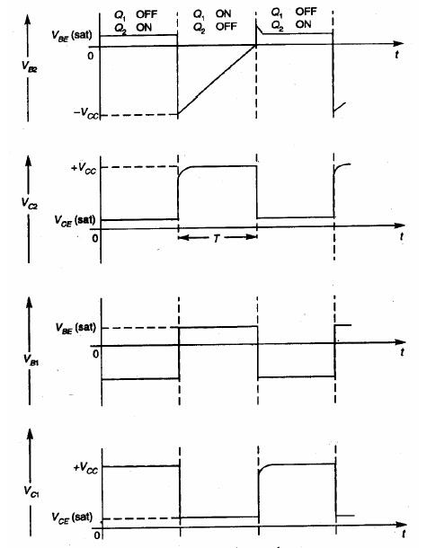

The duration of the quasi-stable state (Q = 1) is determined by the two components R
and C. Because the capacitor only charges to half the total range (from -5 volts to 0, while charging towards +5 volts), the duration of the output pulse is 0.693RC, where 0.693 is the natural logarithm of 2, R is in ohms, and C is in farads. For the component values shown here, the timing interval is 0.693 × 15,000 × 0.0001 = 1.04 seconds. So this circuit will produce a 1-second pulse each time it is triggered.
If the T input has already returned to logic 0, C will rapidly recharge through the 1K
collector resistor and be ready for another input trigger signal. If T remains at logic 1, C will remain discharged until T drops again to logic 0. Then C will fully recharge in about 0.5 second and be ready for another trigger signal.

Lecture # 6

1) Synopsis: Introduction to Bistable multivibrator

2) Target: To study and understand (a) working of Bistable multivibrator

3) Introduction
4) Revision / Prerequisites
Concept of multivibrators
5.1) Concept #1
A bistable circuit is one which can exit indefinitely in either of two stable states and
which can be induced to make an abrupt transition from one state to the other by means of external excitation. Bistable Multivibrator is a two stage regenerative amplifier. Such
interconnected amplifiers pairs are known as Eccles Jordan circuit, Flip-Flop and Binary.
Bistable Multivibrator has 2 astable states. Only the application of a suitable trigger pulse
makes the circuit to change to the other stable state. Thus one trigger pulse causes the
multivibrator to flip from one state to another and the next pulse causes it to flop back to its original state.
As shown here, the circuit we're looking at really is nothing more than two basic
inverters, each taking its input from the other's output. If, when power is first applied, Q1
turns on, its output will be logic 0. This will be applied to Q2's input resistor, keeping Q2 turned off so that its output will be logic 1. This logic 1 will be applied back to Q1's input resistor, keeping Q1 turned on and holding the entire circuit locked into this stable state.
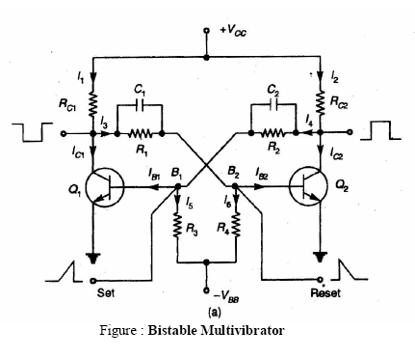

On the other hand, if Q1 stays off at power-up, it will apply a logic 1 to Q2's input,
thus turning Q2 on. The resulting logic 0 output from Q2 will in turn hold Q1 off. The circuit will then remain in this stable state indefinitely.
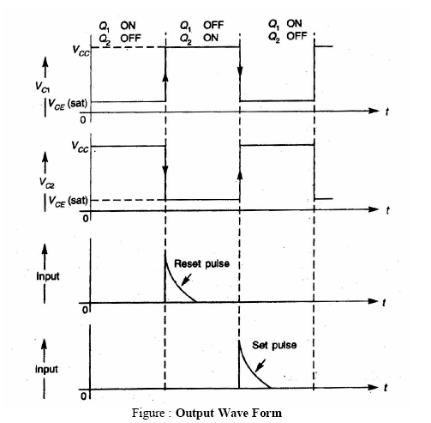
Because this circuit has two possible logical states, it is known technically as a
multivibrator. Because it has two possible stable states, it is a bistable multivibrator. It is also the most basic possible binary latch circuit. In the next few experiments we'll look at ways to expand this circuit and modify its behavior. But first, we'll examine the operation of this basic circuit.

Application
• Bistable multivibrator is used as counters and storing of binary information.
• It is used as frequency divider in timing circuits.
• It can also be used for generation of pulses.

Lecture # 7

1) Synopsis: Introduction to sweep generator

2) Target: To study and understand (a) working of sweep generator
3) Introduction
4) Revision / Prerequisites
Concept of sweep generator
5.1) Concept #1

A linear time base generator or sweep generator is one that provides an output
waveform, a portion of which exhibits a linear variation of voltage or current with time.
The voltage – time base circuit finds a major application in CRO. Among several
methods to achieve sweep linearity, the Miller circuit and Bootstrap circuit are commonly
used. In the Miller circuit, an operational integrator is used to convert a step into a ramp
waveform. In the Bootstrap circuit, a constant current is approximated by maintaining nearly constant voltage across a fixed resistor in series with a capacitor.
5.2) Concept #2
Bootstrap sweep generator
The bootstrap circuit illustrated in figure given below is a commonly used method for
achieving a constant charging current. Here, transistor Q1 acts as a switch and Q2 as an
emitter follower which is connected across capacitor C. Therefore, the output voltage V0 will be approximately equal to the voltage across C. The transistor, therefore, provides a low resistance output terminal for the saw-toothed generator.
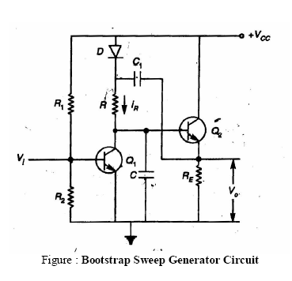

Initially, Q1 is ON and Q2 is OFF. Hence, C1 is charged to the supply voltage Vcc
through diode D and the output voltage V0 is zero. When a negative pulse, as shown in
waveform figure, is applied to the base of Q1 and Q1 is turned OFF. Now, capacitor C1
discharges and capacitor C starts charging through resistor R. As a result, the base voltage of Q2 and V0 start increasing from zero volts. Therefore, diode D becomes reverse biased. The value of capacitor C1 is much larger than that of capacitor C. The voltage across R remains substantially constant throughout the charging process and thus the charging current (iR) is maintained constant. So, capacitor C is charged with a constant current which causes the voltage across C, i.e. the output voltage V0 to increase linearly with time with the relation, V0 = Vcct/RC.

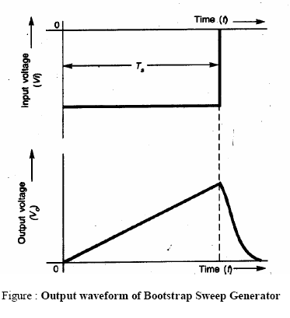
When the negative pulse at the input is removed, C discharges through Q1 and V0
reduces to zero. Then capacitor C1 again charges to supply voltage Vcc through diode D.
The bootstrap sweep circuit is called so because the circuit itself pulls up by its own
bootstrap.

